

***FOUNDED MARCH 1971*** [***www.Irishhistoryroundtable.org***](http://www.Irishhistoryroundtable.org) ***June 2024***

***Joyce’s Ulysses as Live Entertainment***

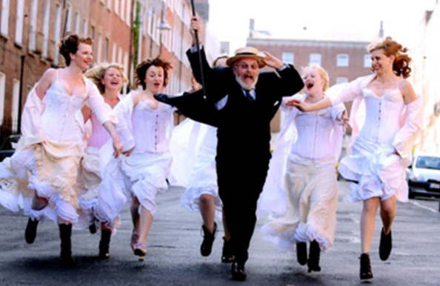

**For our June 18, 2024, meeting of the IHRT, we are pleased to welcome Karen Ponzio, artist, poet, entertainer, with a homage to Joyce’s Ulysses. KP, as she is called, will be sharing readings selected from James Joyce's Ulysses that celebrate the poetic and musical nature of the work. It is her belief that all of Joyce's writings were meant to be read in true entertainment style, out loud, and in the company of others. The performance is free and open to the public. Refreshments served, including Bloom’s favorites, This finishes our lecture series for this year. See you at 7:30pm, Knights of St. Patrick Hall, 1533 State St., New Haven. Check website for changes.** A person with curly hair wearing glasses
Karen has been involved in various creative endeavors over the last 30 years. She has been in the healing arts, written poetry, prose and made drawings. She has shared her poems and artwork at live shows in the New Haven area and has her own radio show focusing on literature and music as well for CygnusRadio.com. She is currently arts/culture journalist for the New Haven Independent. An avid fan of all things Joycean, she was part of the extremely entertaining Bloomsday celebration at Best Video.

***Upcoming Events*:** Irish Book Club, Colm Toibin’s *Long Island*. July 11th. 4pm. Pool optional. Contact: 203.288.9035. **Remember**: Summer Recess for IHRT during July/August. See you next September.

CT Irish Festival: June 22-23, at IACC, East Haven.